V.VENKATA KUMAR REDDY
192311350
CSA4308:INTERNET PROGRAM

21).<!DOCTYPE html>
<html>
<head>
<title>Online Job Portal</title>

<style>
body {
font-family: Arial;
background: #f2f2f2;
text-align: center;
}

h1 {
color: #1565c0;
}

.box {
background: white;
width: 300px;
margin: 15px auto;
padding: 15px;
border-radius: 10px;
box-shadow: 0 0 8px gray;
}

h2 {
color: #333;
}

li {
list-style: none;
padding: 6px;
}
</style>

</head>

<body>

<h1>Online Job Portal</h1>

<div class="box">
<h2>Admin</h2>
<ul>
<li>Login</li>
<li>Approve Director</li>
<li>View Users</li>
<li>View Reports</li>
</ul>
</div>

<div class="box">
<h2>Director</h2>
<ul>
<li>Register</li>
<li>Login</li>
<li>Post Vacancy</li>
<li>View Vacancy</li>
<li>View Applied Users</li>
<li>Logout</li>
</ul>
</div>

<div class="box">
<h2>User</h2>
<ul>
<li>Register</li>
<li>Login</li>
<li>Search Vacancy</li>
<li>Filter by Location</li>
<li>Filter by Category</li>
<li>Apply for Vacancy</li>
<li>Logout</li>
</ul>
</div>

</body>
</html>

OUTPUT:
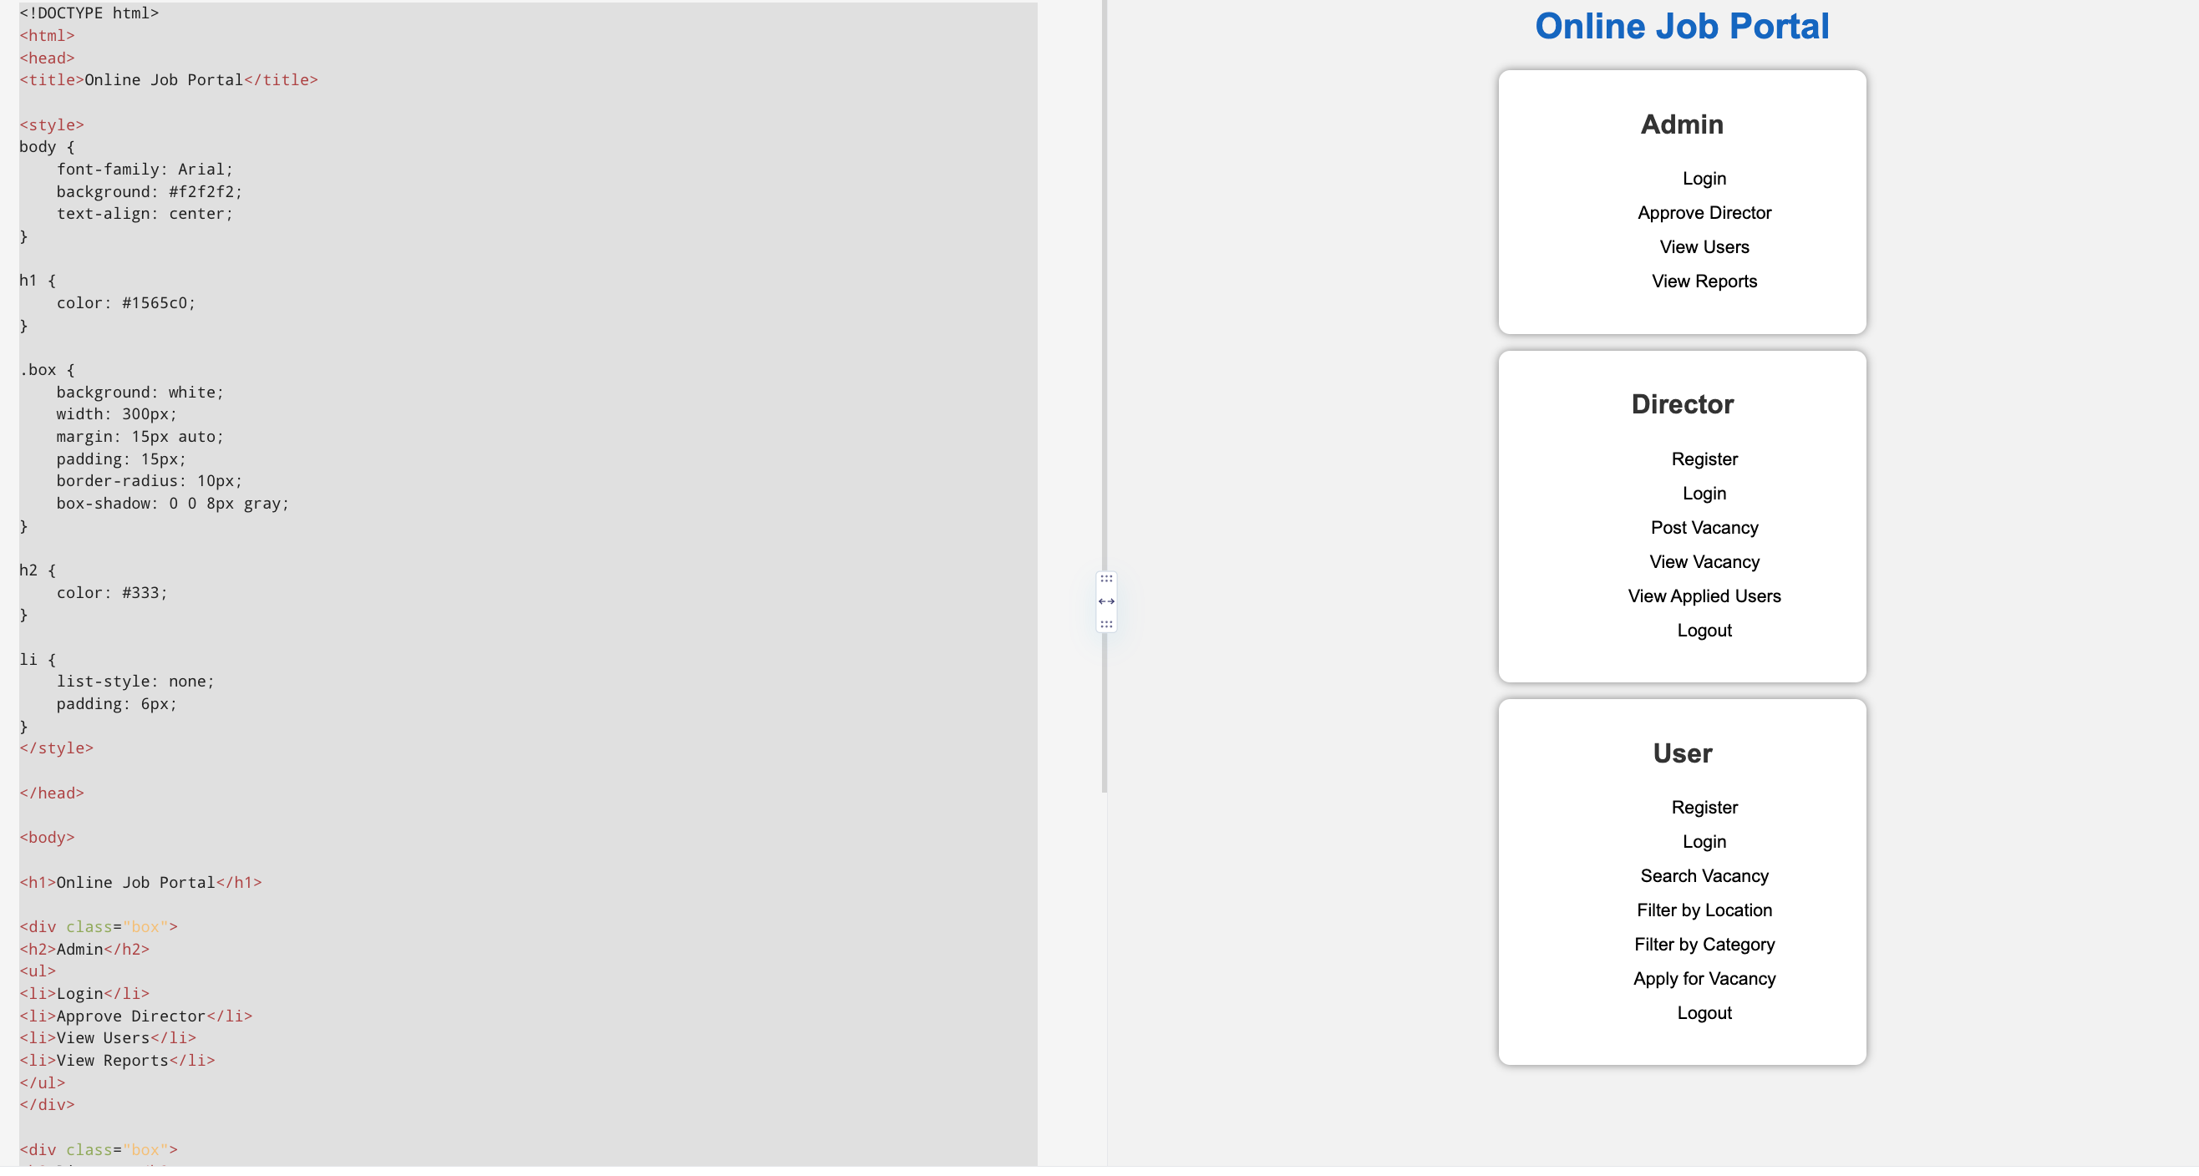

22).<!DOCTYPE html>
<html>
<head>
<title>Solid Waste Management</title>

<style>
body {
font-family: Arial;
background: #e8f5e9;
text-align: center;
}

h1 {
color: #2e7d32;
}

.box {
background: white;
width: 320px;
margin: 15px auto;
padding: 15px;
border-radius: 10px;
box-shadow: 0 0 8px gray;
}

h2 {
color: #388e3c;
}

li {
list-style: none;
padding: 6px;
}
</style>

</head>

<body>

<h1>Solid Waste Management</h1>

<div class="box">
<h2>Administrator</h2>
<ul>
<li>Login</li>
<li>Create Garbage Bin</li>
<li>Update/Delete Garbage Bin</li>
<li>Assign Best Route</li>
<li>Manage Driver</li>
<li>View Garbage Report</li>
<li>View Complaints</li>
</ul>
</div>

<div class="box">
<h2>General Public</h2>
<ul>
<li>Register</li>
<li>Login</li>
<li>Register Complaint</li>
<li>My Complaint & Status</li>
</ul>
</div>

<div class="box">
<h2>Driver</h2>
<ul>
<li>Login</li>
<li>Check Daily Work</li>
<li>Choose Best Route</li>
<li>Update Garbage Load</li>
</ul>
</div>

</body>
</html>

output:
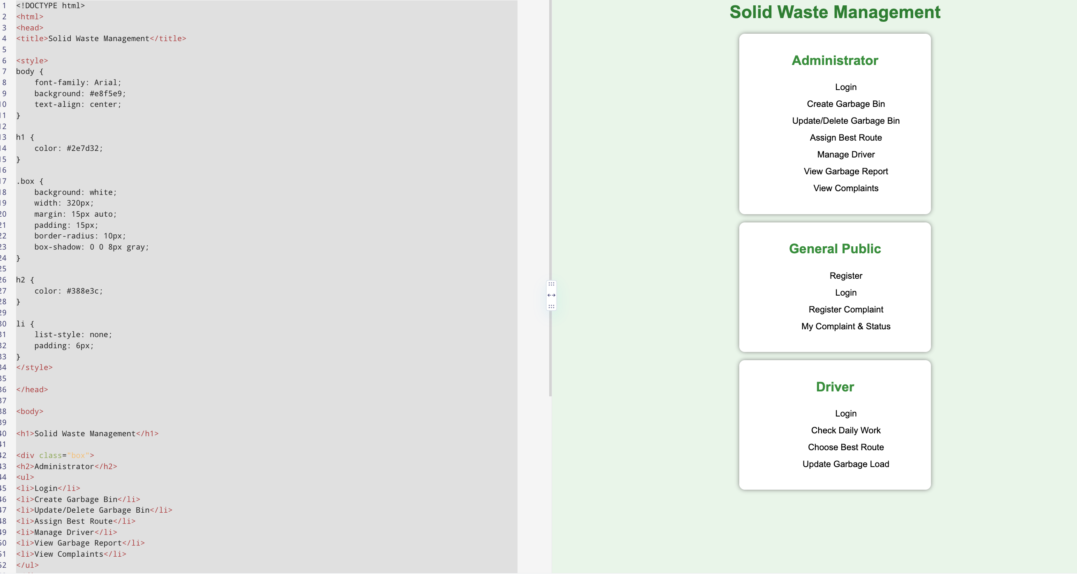

23)
.<!DOCTYPE html>
<html>
<head>
<title>Blood Management System</title>

<style>
body {
font-family: Arial;
background: #ffebee;
text-align: center;
}

h1 {
color: #c62828;
}

.box {
background: white;
width: 320px;
margin: 20px auto;
padding: 15px;
border-radius: 10px;
box-shadow: 0 0 8px gray;
}

h2 {
color: #d32f2f;
}

li {
list-style: none;
padding: 6px;
}
</style>

</head>

<body>

<h1>Blood Management System</h1>

<div class="box">
<h2>Donor / User</h2>
<ul>
<li>Register</li>
<li>Login</li>
<li>Post Donor Information</li>
<li>My Donor Information</li>
<li>Search Donor Details</li>
<li>Search Blood Bank Details</li>
<li>Logout</li>
</ul>
</div>

<div class="box">
<h2>Hospital</h2>
<ul>
<li>Register</li>
<li>Login</li>
<li>Post Blood Bank Information</li>
<li>Update Blood Group Status</li>
<li>View Blood Bank Details</li>
<li>Logout</li>
</ul>
</div>

</body>
</html>

OUTPUT:
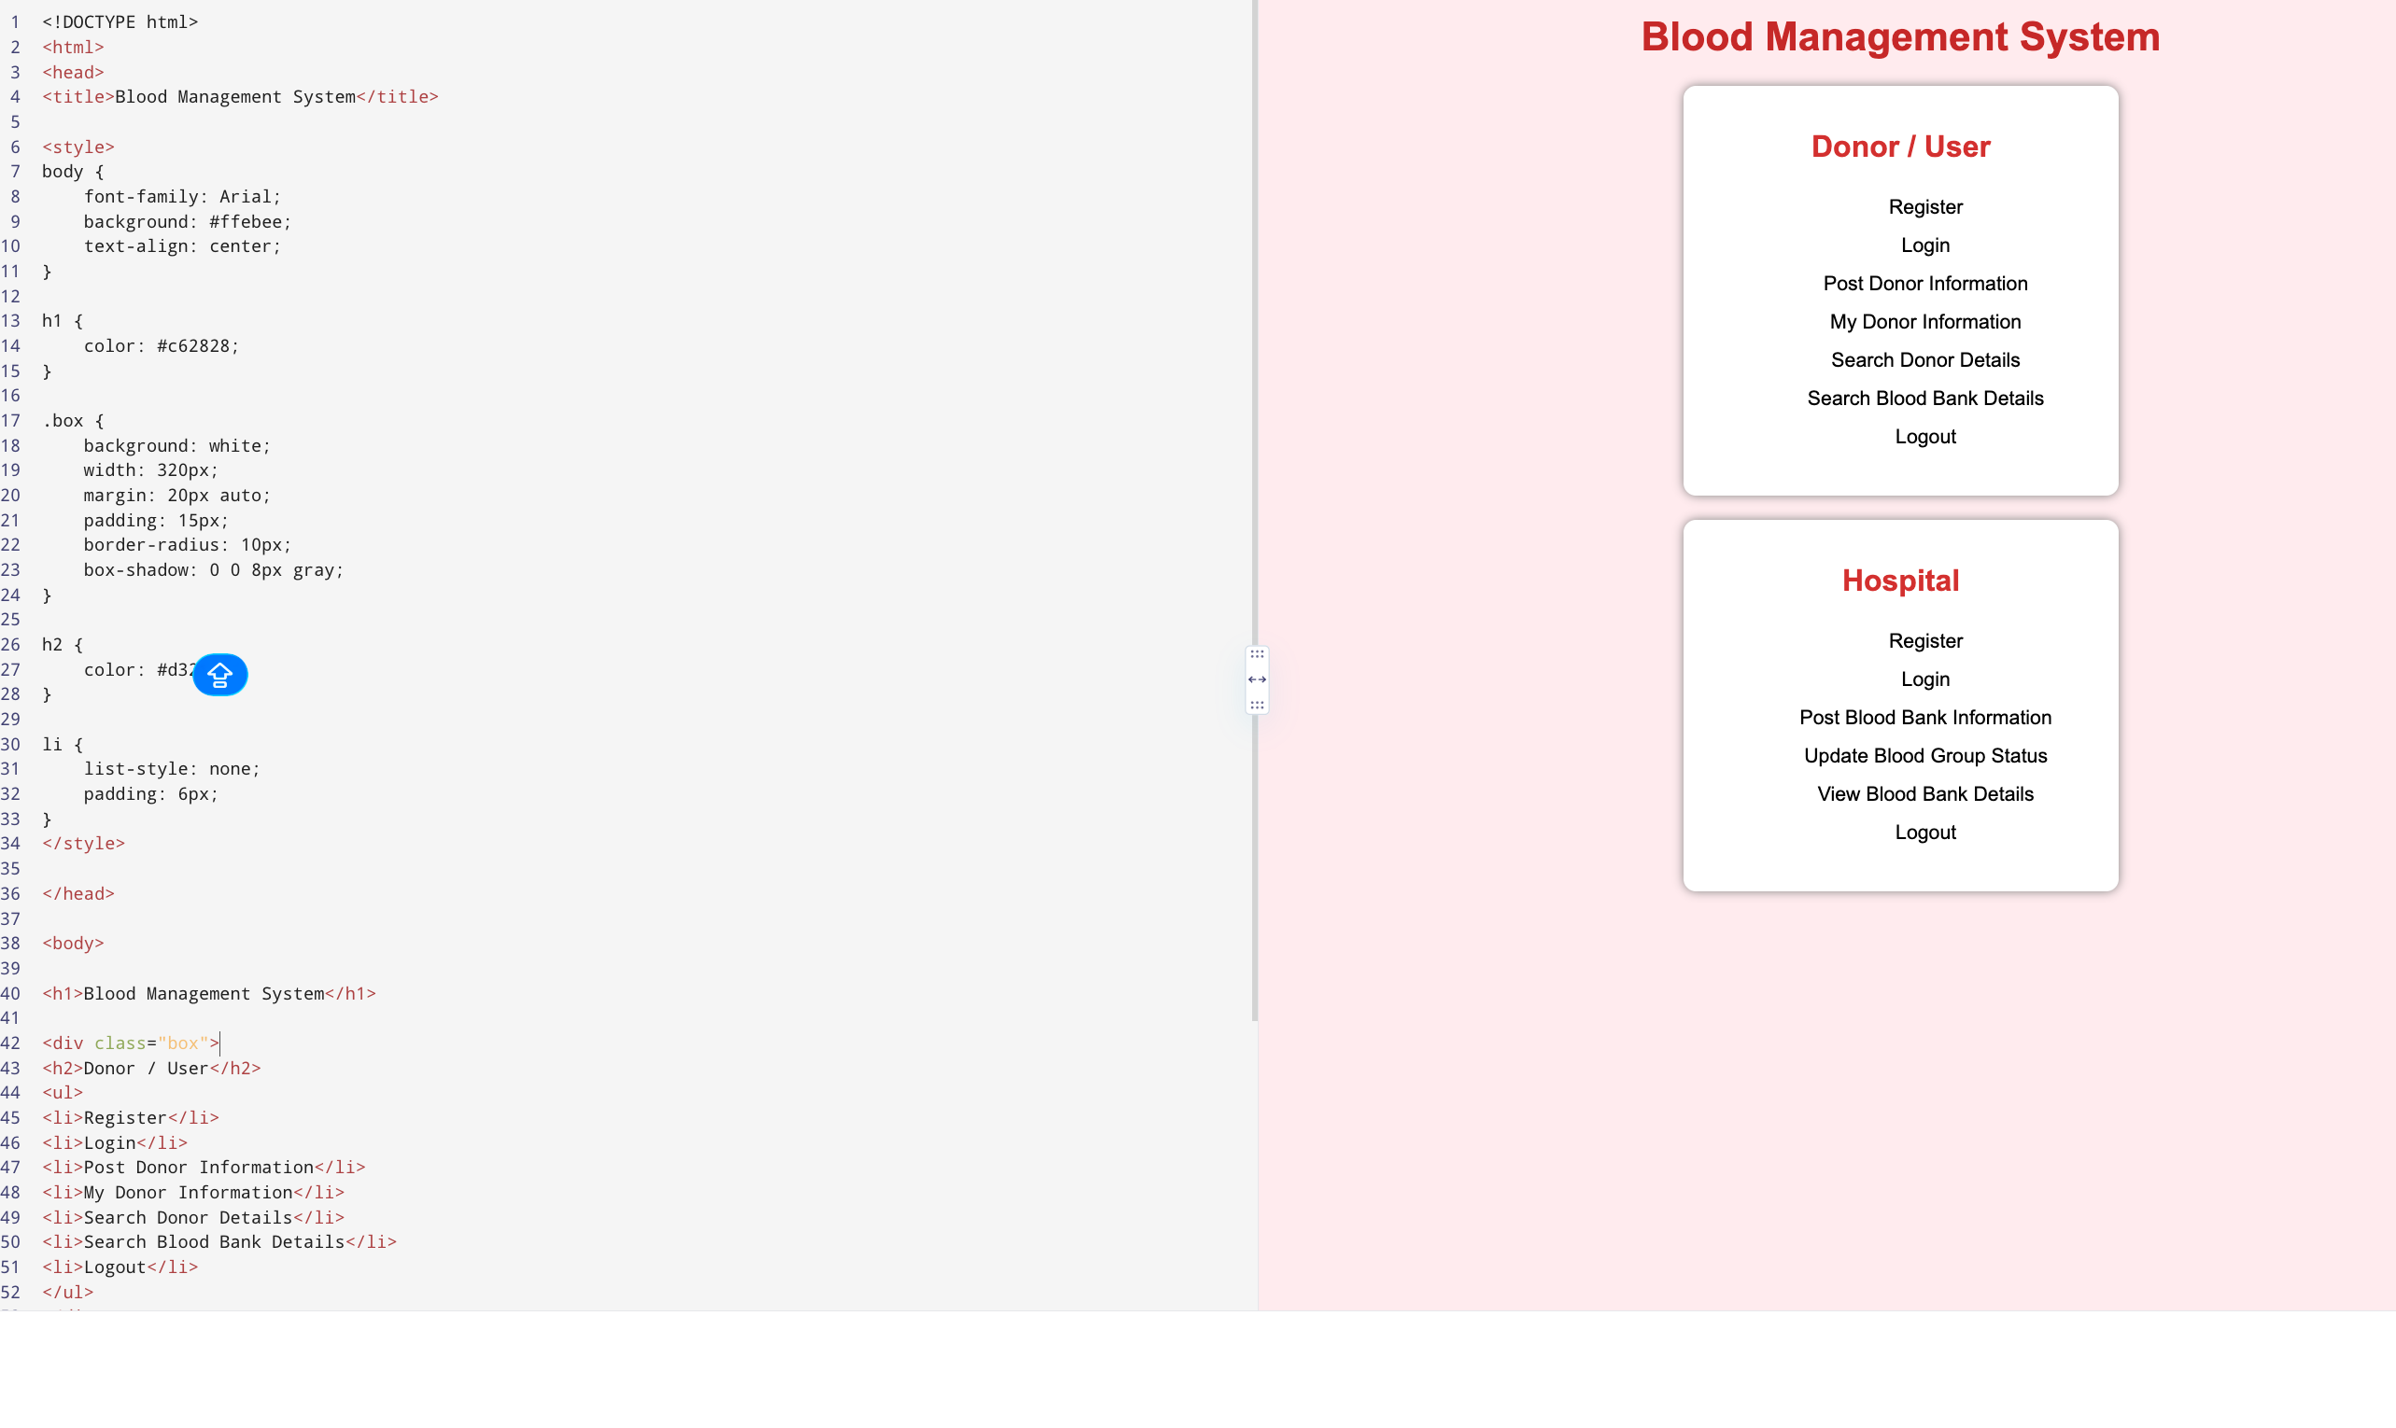

24).

<!DOCTYPE html>
<html>
<head>
<title>Wanderlust Travels</title>

<style>
body {
font-family: Arial;
background: #e3f2fd;
text-align: center;
}

h1 {
color: #1565c0;
}

.box {
background: white;
width: 320px;
margin: 20px auto;
padding: 15px;
border-radius: 10px;
box-shadow: 0 0 8px gray;
}

h2 {
color: #1976d2;
}

li {
list-style: none;
padding: 6px;
}
</style>

</head>

<body>

<h1>Wanderlust Travels</h1>

<div class="box">
<h2>User</h2>
<ul>
<li>Register</li>
<li>Login</li>
<li>View Food Details</li>
<li>View Hotel Details</li>
<li>View Route Details</li>
<li>Book Accommodation</li>
</ul>
</div>

<div class="box">
<h2>Admin</h2>
<ul>
<li>Login</li>
<li>Post Tourism Details</li>
<li>Manage Food Details</li>
<li>Manage Hotel Details</li>
<li>Manage Route Details</li>
<li>View Booking Details</li>
</ul>
</div>

</body>
</html>

OUTPUT:
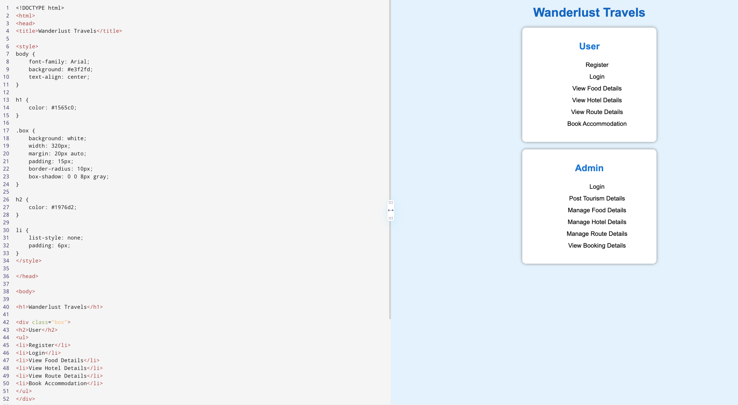

- .
<!DOCTYPE html>
<html>
<head>
<title>Vehicle Breakdown Assistance</title>

<style>
body {
font-family: Arial;
background: #fff8e1;
text-align: center;
}

h1 {
color: #e65100;
}

.box {
background: white;
width: 320px;
margin: 20px auto;
padding: 15px;
border-radius: 10px;
box-shadow: 0 0 8px gray;
}

h2 {
color: #ef6c00;
}

li {
list-style: none;
padding: 6px;
}
</style>

</head>

<body>

<h1>Vehicle Breakdown Assistance</h1>

<div class="box">
<h2>User</h2>
<ul>
<li>Register</li>
<li>Login</li>
<li>Search Mechanic</li>
<li>View Google Location</li>
<li>Post Feedback</li>
<li>My Profile</li>
</ul>
</div>

<div class="box">
<h2>Admin</h2>
<ul>
<li>Login</li>
<li>Provide Approval</li>
</ul>
</div>

<div class="box">
<h2>Mechanic</h2>
<ul>
<li>Register</li>
<li>Login</li>
<li>Post Business</li>
<li>Manage Business</li>
<li>View Feedback</li>
</ul>
</div>

</body>
</html>

OUTPUT:
